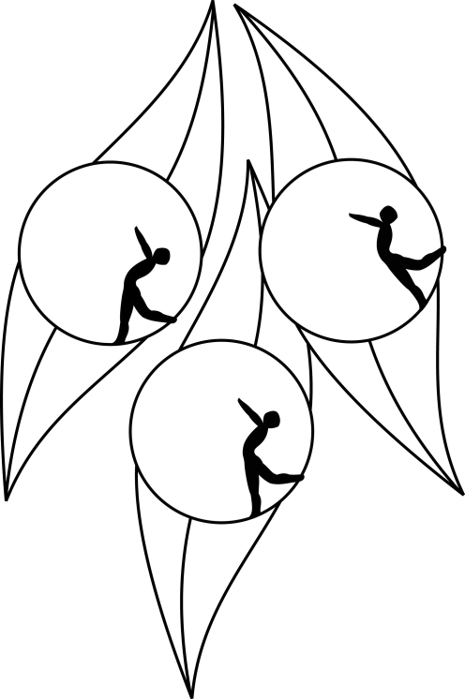
SOUTH AUSTRALIAN ICE SKATING ASSOCIATION Inc.

Results

TEST SESSION

13 August 2011
Ice Arena, Thebarton

Congratulations to the following skaters:

Senior
Jessinta Martin

Primary
James Min

Pre-Primary Figure Pattern
Alyce Naylor
Elysha Glaser

