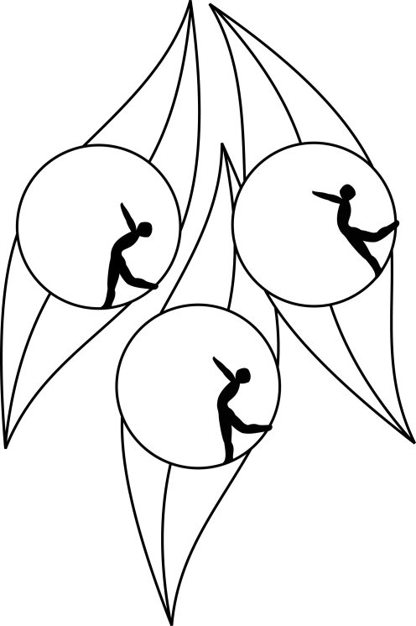
Results
South Australian Ice Skating Association Inc
Test Session

5 September 2010
Ice Arena, Thebarton

Congratulations to the following skaters:

Primary
Giuseppe Triulcio

Preliminary
James Sothea Min

