PREANNOUNCEMENT
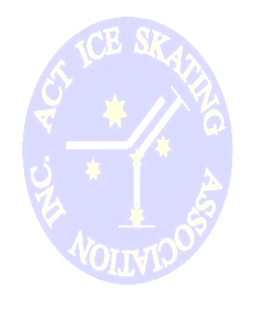
REG PARK ARTISTIC COMPETITION 2012

The Reg Park Artistic Competition will be held again in 2012 over the same weekend as the National Federation Challenge and will incorporate all skating levels from Aussie Skate to Senior and Adult Artistic events

WILL BE HELD SUNDAY SEPTEMBER 9th
AT THE PHILLIP SWIMMING AND ICE SKATING CENTRE, ACT

Potential competitors and coaches please note:
- New ISA technical guidelines for Artistic competitions will be in place as per ISA communication #38 of 2012
- For some skaters this may require a change in program duration & content from that competed with earlier in 2012

Further enquiries should be directed to the competition convenor Mary-Ann Leong by email: comp@actisa.asn.au

WE LOOK FORWARD TO WELCOMING YOU TO OUR EVENT

