PREANNOUNCEMENT
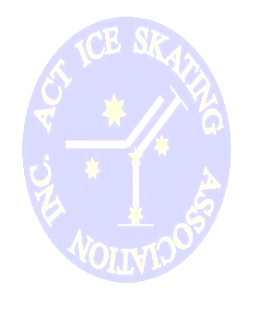
NATIONAL FEDERATION CHALLENGE 2012

National Federation Challenge incorporating non-championship singles (Aussie Skate, preliminary to pre-primary and adult freeskating events), solo dance and theatre-on-ice

WILL BE HELD FRIDAY SEPTEMBER 7th and SATURDAY SEPTEMBER 8th
AT THE PHILLIP SWIMMING AND ICE SKATING CENTRE, ACT

Potential competitors and coaches please note:
- Most Aussie Skate levels are likely to be skated on Friday September 7th to ensure ice availability for all divisions
- Aussie Skate levels will be judged according to ISA Aussie Skate competition guidelines
- New ISA technical regulations regarding eligibility for adult events and IJS level elements will be in place as recently announced (ISA technical regulation communications #36 and #37 of 2012)

Further enquiries should be directed to the competition convenor
Mary-Ann Leong by email: comp@actisa.asn.au

WE LOOK FORWARD TO WELCOMING YOU TO OUR EVENT

